Problem 1
Given the polynomial $p\left(x\right)={\left(x-2\right)}^{9}=x^{9}-18x^{8}+144x^{7}-672x^{6}+2016x^{5}-4032x^{4}+5376x^{3}-4608x^{2}+2304x-512$.
Compare $p\left(x\right)$ on the interval $x=\left[1.920, 2.080\right]$ when evaluated via its coefficients and when evaluated using its simplified form.
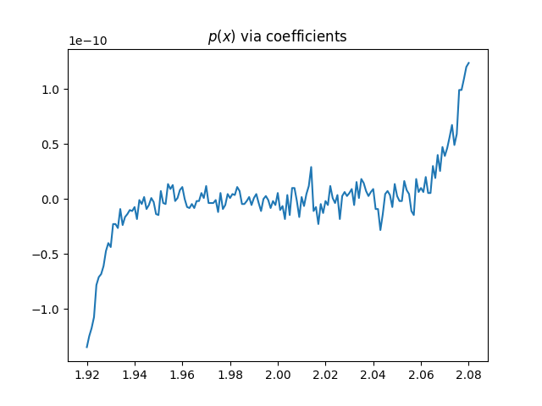
Figure 1
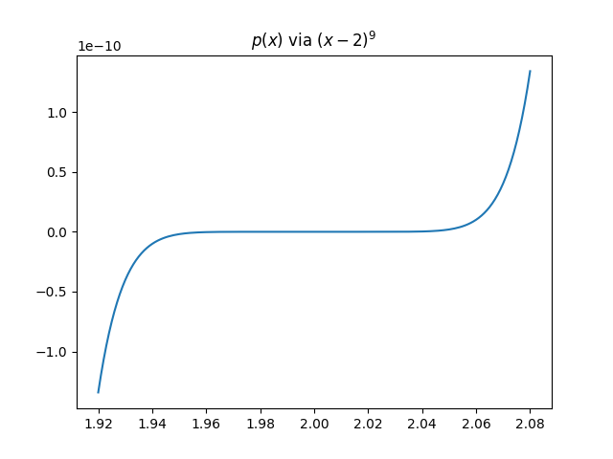
Figure 2
The noise seen in figure 1 is likely due to the nature of floating-point arithmetic. Error is accumulated during the addition and subtraction of multiple values that are very close to zero. The values being added are likely to have very different ranges, with some being much smaller than others. Digits are lost in each addition, and error accumulates. The plot generated by Figure 2 is more accurate since it avoids repeated addition and subtraction and therefore accumulates less error.

Problem 2
For given calculations, provide a method to avoid error by cancellation.
- $\sqrt{x+1}-1$ for $x≃0$
In this case, when $x≪1, x+1=1$. This results in a false result of zero. This can be avoided by multiplying by the reciprocal.
$$\sqrt{x+1}-1$$
$$(\frac{\sqrt{x+1}+1}{\sqrt{x+1}+1})(\sqrt{x+1}-1)$$
$$\boxed{\frac{x}{\sqrt{x+1}+1}}$$
This solution avoids dividing by zero while successfully preventing cancellation of the numerator when $x≃0$.
- $\sin\left(x\right)-sin⁡(y)$ for $x≃y$
Since $sin(x)$ and $sin(y)$ will evaluate to very similar floating-point values, they will falsely cancel to zero. This can be avoided using a sum-to-product formula.
$$sin\left(α\right)-\sin\left(β\right)= 2\sin{(\frac{α-β}{2})cos⁡(\frac{α+β}{2}})$$
$$2\sin\left(\frac{x-y}{2}\right)cos⁡(\frac{x+y}{2})$$
This calculation evaluates $x-y$ before applying the sin function, which will allow x and y to be much closer to equal before canceling the result to zero.

- $\frac{1-cos⁡(x)}{sin⁡(x)}$ for $x≃0$
This equation can be solved by multiplying by the reciprocal and then applying trigonometric identities.
$$\frac{1-cos⁡(x)}{sin⁡(x)}$$
$$\frac{1+cos⁡(x)}{1+cos⁡(x)}*\frac{1-cos⁡(x)}{sin⁡(x)}$$
$$\frac{1-\cos^{2}{(x)} }{sin⁡(x)(1+\cos\left(x\right))}$$
$$\frac{\sin^{2}(x)}{sin⁡(x)(1+cos⁡(x)}$$
$$\boxed{\frac{sin⁡(x)}{1+cos⁡(x)}}$$
This calculation avoids cancellation by subtraction in the numerator or denominator and will produce more accurate results when $x≃0$.

Problem 3
Given the function $f\left(x\right)=\left(1+x+x^{3}\right)\cos\left(x\right)$, use a second-degree Taylor polynomial about $x_{0}=0$ to approximate $f\left(0.5\right)$ and analyze the error.
$$P_{2}\left(x\right)=f\left(x_{0}\right)+ f^{'}\left(x_{0}\right)\left(x-x_{0}\right)+ \frac{f^{''}\left(x_{0}\right)}{2!}{\left(x-x_{0}\right)}^{2}$$
$$f\left(0.5\right)=\frac{13}{8}cos⁡(0.5)$$
$$f^{'}\left(x\right)=\left(1+3x^{2}\right)\cos\left(x\right)-(1+x+x^{3})sin⁡(x)$$
$$f^{'}\left(0.5\right)= \frac{7}{4}\cos\left(0.5\right)-\frac{13}{8}sin⁡(0.5)$$
$$f^{''}\left(x\right)=\left(-1+5x-x^{3}\right)cos\left(x\right)+\left(-2-6x^{2}\right)\sin\left(x\right)$$
$$f^{''}\left(0.5\right)=\frac{11}{8}\cos\left(0.5\right)-\frac{7}{2}sin⁡(0.5)$$

$$\boxed{P_{2}\left(x\right)=\frac{13}{8}\cos\left(0.5\right)+\left(\frac{7}{4}\cos\left(0.5\right)-\frac{13}{8}\sin\left(0.5\right)\right)\left(x-0.5\right)+\frac{1}{2}\left(\frac{11}{8}\cos\left(0.5\right)-\frac{7}{2}\sin\left(0.5\right)\right){\left(x-0.5\right)}^{2}}$$

Evaluating this expression in python for $x=0.5$ returns:
$$\boxed{P_{2}\left(0.5\right)=1.4260716630718557}$$
The upper bound for the error of this value can be approximated as follows, where $M$ is the upper bound of the third derivative on the interval $(0, 0.5)$.
$$\left|R_{2}\left(0.5\right)\right|≤\frac{M}{3!}{\left|0.5\right|}^{3}$$
$$f^{'''}\left(x\right)=\left(3-9x^{2}\right)\cos\left(x\right)+\left(1-17x+x^{3}\right)\sin\left(x\right)$$
The upper bound of this function is $M=3$, and thus the upper bound for the error is

p2 = lambda x: (13/8)*np.cos(0.5)+((7/4)*np.cos(0.5)-(13/8)*np.sin(0.5))*(x-0.5)+0.5*((11/8)*np.cos(0.5)-(7/2)*np.sin(0.5))*(x-0.5)**2

